Exercise - Set up a Log Analytics workspace and Azure Monitor VM Insights

1. Create a Log Analytics workspace.
2. Configure the Log Analytics workspace permissions model for the environment you're supporting.
3. Create two virtual machines and onboard both to Azure Monitor VM Insights.

1.

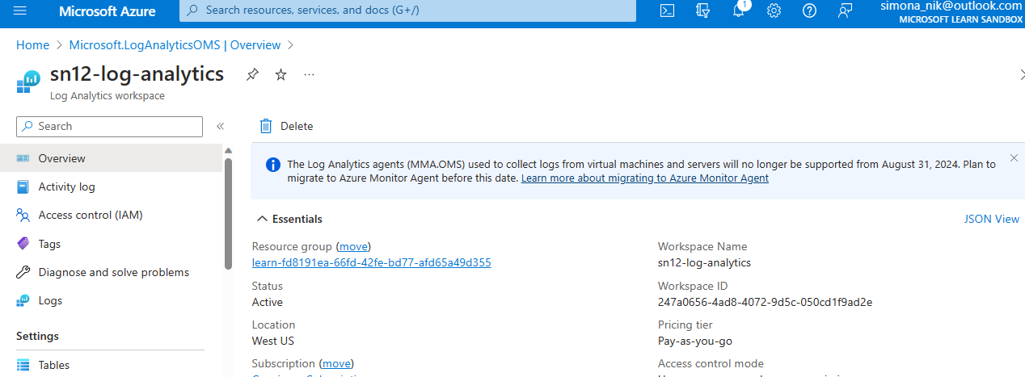

Then we set up the environment with writing commands in cloud shell

az vm create \

--resource-group learn-fd8191ea-66fd-42fe-bd77-afd65a49d355 \

--location westus \

--name SampleVM2 \

--image UbuntuLTS \

--admin-username azureuser \

--generate-ssh-keys \

--verbose

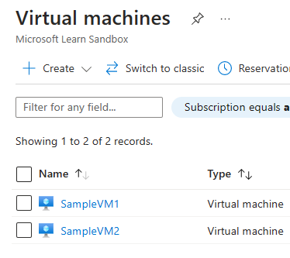

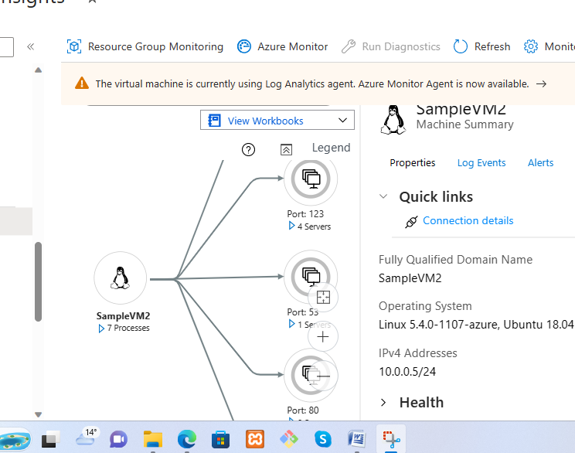

We can see the log events

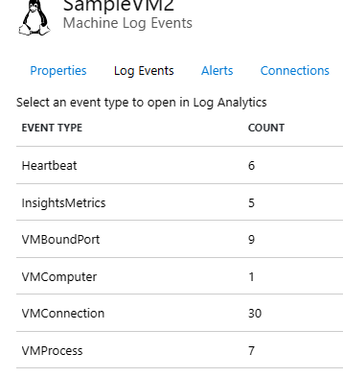 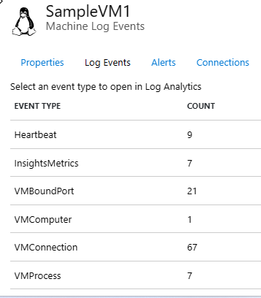

Build a query by using the query pane

We go to queries and select and run the following

